**Applications of PLA**

The produced PLA is, among others, ideal for packaging, it can be transparent, opaque, flexible or rigid, with a gloss or transparency comparable to polystyrene and a rigidity modulus comparable to polyesters. Its aroma and odour-barrier properties coupled with resistance to attacks by fat make it a unique polymer for food packaging and it has the same heat-sealing capacities as polyolefin.

**

Thermoforming is a manufacturing process where a plastic sheet is heated to a pliable forming temperature, formed to a specific shape in a mold, and trimmed to create a usable product.

Applications: Cups, straws, containers, lids, trays, blisters, clamshells, and other products for the food, medical, and general retail industries.

**

It is a material mainly made from natural or synthetic sources. This material will convert into the making of textile yarns and fabrics; woven, knitted, nonwoven, and carpets.

Applications: Gloves, masks, caps, cloth, baby diapers, gowns and other products that are applied in medical, agriculture, textile industries.

**Film**.  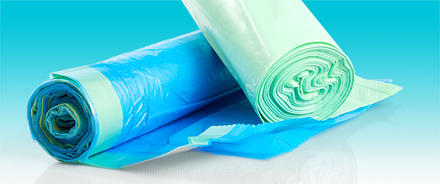 

Plastic film is a thin continuous polymeric material.

Applications:  [packaging](https://en.wikipedia.org/wiki/Packaging), [plastic bags](https://en.wikipedia.org/wiki/Plastic_bag), [labels](https://en.wikipedia.org/wiki/Label), building construction, landscaping, electrical fabrication, [video tape](https://en.wikipedia.org/wiki/Video_tape).

**Injection molding.** 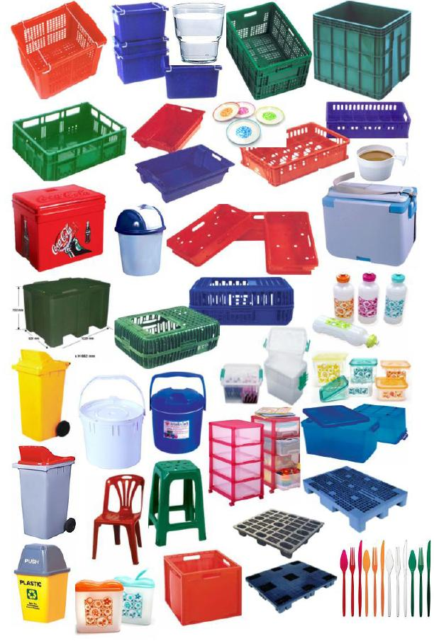

Injection molding is a manufacturing process for producing parts by injecting molten material into a mould. It is is widely used for manufacturing a variety of parts, from the smallest components to entire body panels of cars.

Applications: computer and electronics, automotive components, toys, instrumentation, household equipment, cable assemblies.

**Bottles.** 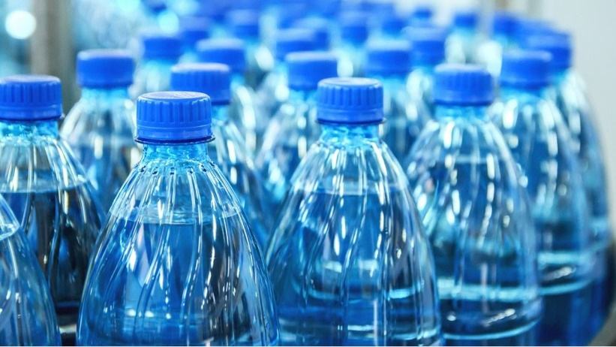

**Rotomolding.** 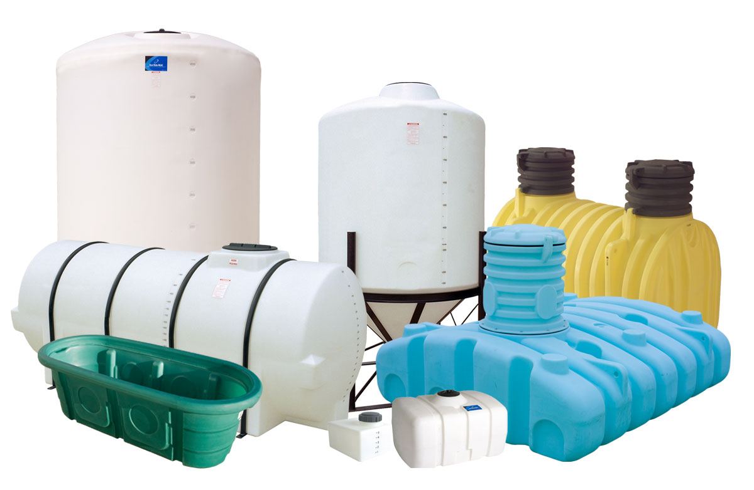

Rotomolding or rotational molding is a production process to form hollow parts of limitless size. This is a cost-effective method to produce large plastic parts.

Applications: containers, tanks, materials handling, medical products.

**3d Printing.** 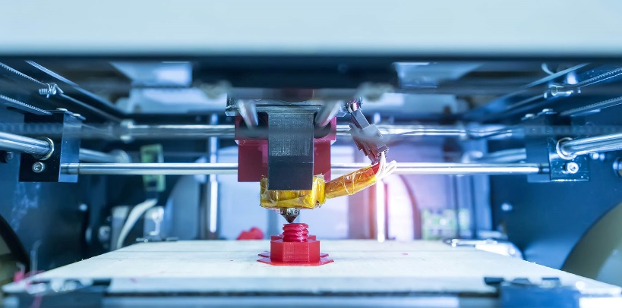

Three-dimensional (3-D) printing is an additive manufacturing process that creates a physical object from a digital design. The process works by laying down thin layers of material in the form of liquid or powdered plastic, metal or cement, and then fusing the layers together.

It is used in medicine, manufacturing, architecture, custom art and design.